ChatCompletions API and Responses API
When using openai or azure openai APIs, we can either use the older ChatCompletion API or the newer (recommended) Responses API.
Examples using the responses API with a reasoning model:
(If not using a reasoning model just ditch that argument).
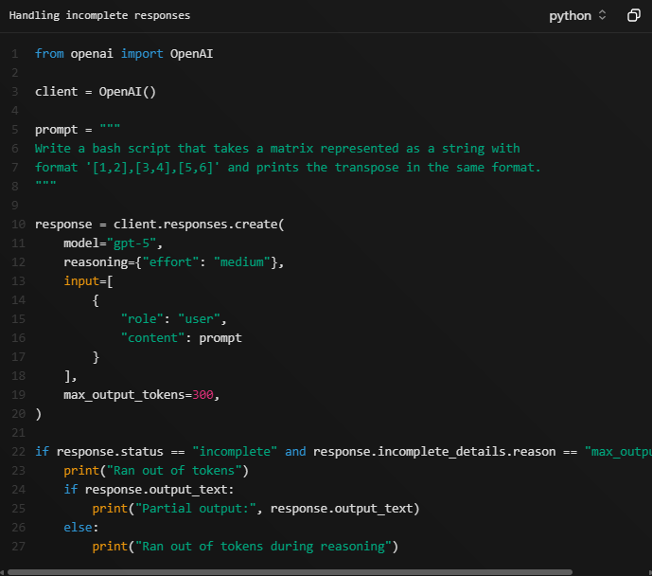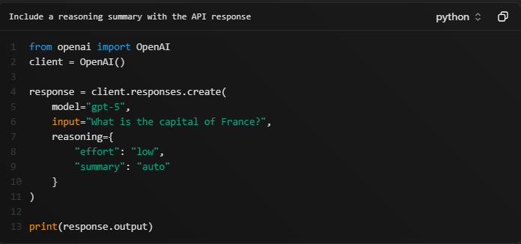 (Reasoning models | OpenAI API)

Configuring Reasoning
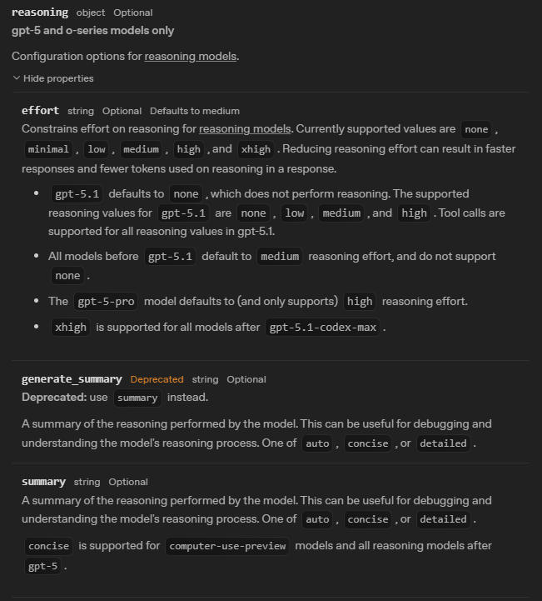
The default reasoning setting depends on the model, and I believe the scenario as well. For example the documentation said that gpt-5.1 the reasoning effort defaults to None, but when using within the agents sdk, it defaults to ‘low’ (I checked using `from agents.models import get_default_model_settings`.

Using Azure OpenAI models with ChatCompletions/Responses API
Seems straightforward:
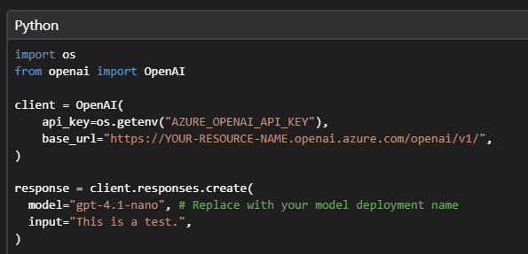(Azure OpenAI Responses API - Azure OpenAI | Microsoft Learn)

Using Azure OpenAI models with Agent SDK

Agents SDK
model=OpenAIChatCompletionsModel(
model=os.getenv("OPENAI_MODEL"),
openai_client=openai_client
),
Everyone I could find online uses this (argument to Agent init). But this is not ideal as if we can use the ResponsesModel, it gives slightly better performance (I read this somewhere on the openai website).
Even this official blog says it: Use Azure OpenAI and APIM with the OpenAI Agents SDK | Microsoft Community Hub Wonder if it automatically uses the responses api or something.
The thing is replacing OpenAIChatCompletionsModel here with OpenAIResponsesModel doesn’t work with the Azure endpoint. The endpoint even says chatcompletion in it.
Sidenote- when using a model directly from openai, just put model=<string name of model>. I believe it auto uses the responses api. If u want u can still wrap it inside OpenAIChatCompletionsModel or OpenAIResponsesModel.

Using Microsoft Agent Framework
I have not used this.
pip install agent-framework –pre
